CAT Grade 12: Additional Practical Activities
SOLUTIONS
It is important that you obtain practice in thinking for yourself first, and in looking through the Ribbon for the necessary commands to complete these activities. You won't get the same value out of the exercises if you simply look at the solutions straight away. So first try doing them by yourself, before looking at the solutions.
Activity 1 – Word processing
Open the document Line Numbers.
1.1 Change the line numbers in the left margin to appear as follows:
- The line numbers must start at 10.
- Only every second line number must be displayed.
- The numbering must restart on each page.
Page Layout Page Setup Layout Tab Line numbers Start at 10, Count by 2, Numbering – Restart each page OK OK
Save and close the document Line Numbers.
Open the document Responsible Use (and use this document for the rest of Activity 1).
1.2 Change the Table of Contents on page 1 as follows:
1.2.1 The TOC must display page numbers instead of hyperlinks on a web page. (Assume that the document will be saved later as a single file web page file for viewing in a web browser.)
References Tab Table of Contents Custom Table of Contents remove check mark from ‘Use hyperlinks instead of page numbers’ under Web Preview OK Do you want to replace... Yes
1.2.2 Remove the heading ‘Responsible use of computers’ from the table of contents, but without removing the heading from the body of the document.
Ensure that the formatting of the heading remains as Arial 24 pt Bold, paragraph ‘after’ spacing 12 pt.
Home tab Styles group Open Styles box (small arrow bottom right) Click on “Responsible use of computers” heading and change to ‘TOC Heading’ style Right click on table of contents Update Field Update entire table OK
Update the TOC Heading style to 24 pt Bold, paragraph ‘after’ spacing 12 pt.
1.2.3 Change the scale of the character spacing of the TOC to 110%.
Select entire TOC right-click TOC Font… Advanced tab Scale 110% OK

1.3 Add a shadowed paragraph border to the paragraph in red under the heading ‘Introduction’. The border must be 5 pt from the text on all 4 sides.
Select paragraph Borders and Shading… select Shadow preset at left Apply to Paragraph Options From text: all boxes 5 pt OK OK
1.4 Create a new label called ‘Image’ and add the caption ‘Image 1: Computer viruses are bad news!’ above the picture under the heading ‘Computer viruses’.
Right-click image Insert Caption… New Label Image OK enter caption text and select position ‘Above selected item’ OK
1.5 Add the screen tip ‘Not used anymore’ to the hyperlink on page 2.
Right-click hyperlink Edit Hyperlink… ScreenTip… enter screen tip text OK OK
1.6 Insert the picture ‘Computer’ as a watermark only on page 3.
Page Layout Breaks Next page section break (add in before and after page 3). Design Watermark Custom watermark Picture watermark Select Picture Insert OK Right click edit header Break ‘Link to previous’ in section 2 & 3. Go to section 1 (still in the header), click on the picture and press delete Repeat for section 3.
1.7 Set the absolute position of the image under the heading ‘Internet access’ to 6 cm below the top margin of the page.
Select image Format Position (in Arrange group) More Layout Options... set Vertical Absolute position 6 cm below Top Margin OK
1.8 Locate the text ‘callmore time’ under the heading ‘Internet access’ on page 3.
Change the footnote to this text that reads ‘Telkom deal’, so that the footnote appears below the text on the page, and not at the bottom of the page.
Also change the number format to .
Right click on footnote Note Options Location footnotes: (change to) Below text Number format Dropdown menu choose correct option Apply.
1.9 Locate the text ‘Computer Use’ under the heading ‘Switching off the computer’.
Create a hyperlink on this text that points to the bookmark ‘ComputerUse’ in the file Green Computing.
Select and right click on text Hyperlink Link to: Existing File or Webpage Current Folder Select ‘Green Computing’ file Click on Bookmark button to the right Select ComputerUse OK OK
1.10 Locate the text ‘The cost of running a computer ... referring to <<>>’ under the heading ‘Switching off the computer’.
Replace the blue placeholder <<>> with a cross reference to the equation on the last page of the document.
Include only the caption text as a cross reference.
elect blue placeholder References Cross-reference (in Captions group) Change Reference type to ‘Equation’ [Equation 1 now appears in list box] change ‘Insert reference to’ to ‘Only caption text’ Insert Close
1.11 Add a text border to the text in blue ‘Paper and ink cost money!’ under the heading ‘Computer equipment and other media’.
Select text Borders and Shading… select Box preset at left Apply to Text OK
1.12 Locate the line under the text ‘Number of times...’.
Replace this line with a red 2 pt horizontal line that is 10 cm wide, and centred across the page under the text.
Delete the existing line Home tab Paragraph group Borders and shading drop down arrow Horizontal Line Double click line to edit change Width: 10, Measure in: Centimeters, Height: 2 pt, Color: Red (use solid color), Alignment: Center OK
1.13 Change the font colour of all instances of the whole word ‘computer’ (case sensitive) to green.
Home tab Editing group Replace in ‘Find what’ type ‘computer’ click More >> check ‘Match case’ and ‘Find whole words only’ in ‘Replace with’ type ‘computer’ click Format – Font… change Font colour to green OK Replace All
Enter the number of times the whole word ‘computer’ (case sensitive) appears in the document, in the red text box on page 4.
[28 times]
1.14 Add an Editor (metadata) property to the document, using your own name as the value.
File Tab Click on Properties top right panel Advanced Properties Custom Tab Name: Editor Type own name in Value box Add OK
1.15 Locate the fields and place holders near the bottom of page 4.
1.15.1 Locate the form field next to the text ‘School name’.
Add help text that will display ‘Enter the name of your school’ when the F1 key is pressed.
Right-click field Properties Add Help Text… click tab Help Key (F1) type required text in box OK [Note: pressing F1 key for this help text will only work if editing of document is restricted to filling in of forms]
Add default text to this form field that reads ‘ABC High’.
Right-click field Properties Default text type ‘ABC High’ OK
1.15.2 Replace the yellow place holder next to the text ‘Document created by’ with the Author field.
Select place holder Insert tab Quick Parts (in Text group) Document Property (or Field…) Author
1.15.3 Set the default value of the check box field next to the text ‘Spelling check performed’ to not checked.
Right-click check box Properties change Default value to ‘Not checked’
1.15.4 Replace the green place holder next to the text ‘Total number of words in document’ with a field that displays the total number of words in the document.
Select place holder Insert Quick Parts Field… NumWords OK
1.16 Locate the flag shape near the bottom of page 4.
Use the fill feature to fill the shape with the Computer picture.
Right-click shape Format Shape… Fill Picture or texture fill click File… select picture Insert
1.17 Locate the equation on the last page of the document. A part of the equation has been left out.
Refer to the following equation and add the part that was left out from the equation in the document:
Right-click equation Equation Object Edit (Or just double-click the equation) type in ‘Cost(R)’ in space provided
1.18 Mark all instances of the word ‘electricity’ as entries for an index.
Find any instance of the word electricity (Ctrl+F) and select the word References Tab Index group Mark Entry Main entry: electricity Mark All
1.19 Now insert an automatic index, with right-aligned page numbers, on the last page of the document. Use the default settings.
Go to last page References tab Index group Insert Index Select ‘right align page numbers’ box OK
Save and close the document Responsible Use.

Activity 2 – Word processing (conditional mail merge)
Open the document Letter to parents and perform the following conditional mail merge:
2.1 Replace the place holders with the corresponding fields in the source spreadsheet Registration.
Mailings Tab Start Mail Merge Letters Select Recipients Use an existing list navigate to correct folder, choose Registration spreadsheet Open OK Replace all yellow fields with the corresponding mail merge field Insert Merge Field.
Use an If...Then...Else mail merge rule to replace the He/She place holder with text based on the Gender field name. If the value of the field is Male, the text ‘He’ must be inserted, otherwise the text ‘She’ must be inserted.
Delete the Green words He/She Mailings Tab Write & Insert Fields group Rules If...Then...Else Field name: Leaner_Gender, Comparison: Equal to, Compare to: Male, Insert this text: He, Otherwise insert this text: She OK
To check if done correctly: right-click on “He” (Merge field) – toggle field codes
{ IF { MERGEFIELD Learner_Gender } = "Male" "He" "She" }
Save the document Letter to parents just before you complete the merge.
2.2 Complete the mail merge, by merging only records 2–7, and save the merged document with the name Letter to parents MERGED.
Mailings tab Finish & Merge Edit individual documents From 2 to 7 OK
Save and close both the documents.

Activity 3 – Spreadsheet
Open the spreadsheet Cellphone Users. Work in the Data worksheet.
3.1 Insert a comment in cell C2 that reads ‘Check cellphone number’.
Right-click cell Insert Comment
3.2 The dates of birth of the users are stored in column D.
Use a function in cell F3 to display the number of the birth month of Sheree Leverington.
Use YEAR function – see solution
3.3 Use an appropriate lookup function in cell G5 to determine the service provider of Ryan Nase.
Note that the first three digits of the cellphone number represent the service provider.
The lookup table required is stored in the Service Providers worksheet.
Use HLOOKUP and LEFT functions – see solution
3.4 Use a formula in cell I8 to calculate Sinikwe Hoyi’s age in 2016 (i.e. how many years old she will be on her birthday in 2016).
Use YEAR and TODAY functions – see solution
3.5 Use a spreadsheet feature to force the user to enter a valid cellphone number (i.e. one that contains exactly 10 digits/characters) in column C.
Add a suitable error message that the user will receive if he/she tries to enter invalid data.
Hint: Use Data Validation.
Select column C Data Data Validation Settings tab Text length change both Minimum and Maximum values to 10 Error Alert type suitable Error message (Accept any Title and Style)
3.6 Use conditional formatting to automatically apply the ‘3 Flags’ icon set format style on all the values in column H.
Use the following categories:
- Red flag: >= 750
- Yellow flag: 400 – 749
- Red flag: 0 – 399
Select column H Conditional Formatting Icon Sets More Rules… Icon Style = 3 Flags Reverse Icon Order (to ensure that red flag appears as first rule) change red flag Type = Number, Value = 750, Change yellow flag Type = Number, Value = 400, OK
3.7 Use conditional formatting to automatically apply a 2-colour scale format style on all the values in column I (Age in 2016).
Change the colours of the minimum and maximum values as follows:
- Minimum (lowest value): green
- Maximum (highest value): blue
Select column I Color Scales More Rules… Format all cells based on their values Format Style = 2-Color Scale Change Lowest Value colour to green, Highest Value colour to blue
3.8 Locate the chart Average data used (MB) per age group and do the following:
- Remove only the Primary Minor Horizontal gridlines.
Select chart Design (in Chart Tools) Add Chart Element Gridlines deselect Primary Minor Horizontal gridlines [Quicker: select relevant gridlines directly on chart and press Delete]
- Insert a linear trend line.
Select chart Design (in Chart Tools) Add Chart Element Trendline select Linear
Your chart should appear as follows:
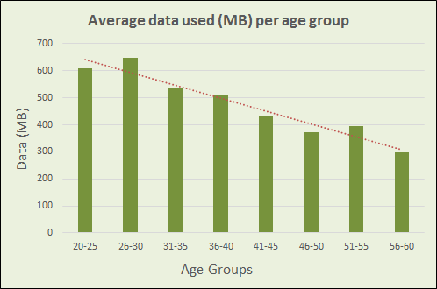

3.9 Locate the chart Gender distribution per age group and do the following:
- Remove the Blank series (there must only be two series, i.e. Males and Females).
Right-click chart Select Data… click on Blank series Remove OK
- Change the ‘Females’ data series to display as clustered columns, similar to the ‘Males’ data series.
Right-click line representing Females data series Change Series Chart Type… change Females series to Clustered Column OK
Your chart should appear as follows:
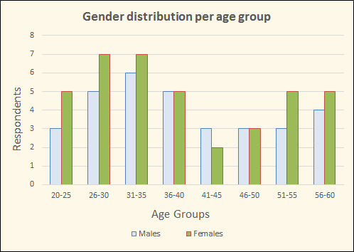
3.10 Locate the pie chart Sample Group and do the following:
- Change the chart to a Doughnut chart.
Right-click chart Change Chart Type… select Doughnut (sub-type of Pie) OK
- The doughnut hole size must be 30%.
Right-click Doughnut series Format Data Series… change Doughnut Hole Size to 30%
- The chart must have any 3-D bevel effect.
Right-click Doughnut series Format Data Series… Effects (5-sided command icon at top) 3-D FORMAT change Top bevel (can also increase Width and Height of bevel to e.g. 12 pt to make it stand out more)
- Show the Leader Lines that connect each data label to its slice.
Right-click Doughnut series Format Data Labels… check Show Leader Lines
Your chart should appear similar to the following:
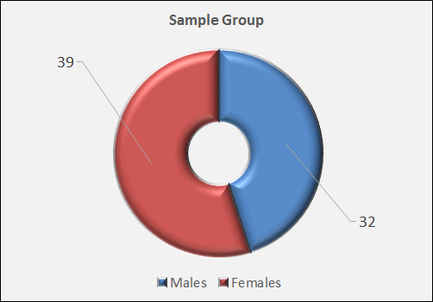
3.11 Filter the data so that those who do not have a cell phone number in the worksheet are not displayed.
Data tab Filter (in Sort & Filter group) click down-arrow in cell C1 (CellNo) Text Filters Contains… enter asterisk (*) in box at right OK
Save and close the spreadsheet.

Activity 4 – Database
Open the database ArtExhibition.
4.1 Make the following changes to the design of the Applications table:
4.1.1 Change a field property of the CellNo field so that the user is forced to enter data in this field AND to accept no duplicates. Do NOT change the primary key. Ignore any warning messages that may appear.
Set Indexed property of CellNo field to Yes (No Duplicates)
4.1.2 Change a field property of the Exhibition field to display check boxes instead of Yes/No.
Select Exhibition field in Design View click Lookup tab at bottom change Display Control to Check Box
4.2 Create a query called Summary based on the Applications table that will display the total amount raised per school per category, as shown in the table below.
Hint: Use the Totals command in the Design tab, and aggregate functions.
Create a query (can use the Wizard), adding only the School, Category and Price fields Design View Click Totals command in Design tab change Total row as follows: School field = ‘Group By’, Category field = ‘Group By’, Price field = ‘Sum’
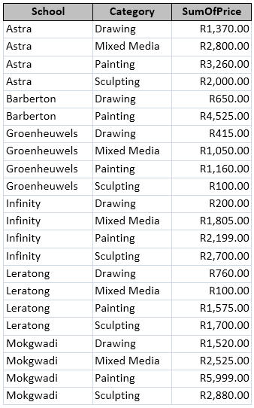
4.3 Import the data of the Contacts worksheet of the School Contact Persons spreadsheet as a linked table into the database. Use the same name as the spreadsheet worksheet for the table.
External Data tab Import & Link group Excel browse for spreadsheet School Contact Persons click bottom radio button ‘Link to the data source by creating a linked table’ OK Next check ‘First Row Contains Column Headings’ Next Finish
4.4 Set the properties of the form Entry Form so that users will not be able to delete any data.
Open form in Design View Property Sheet (in Design tab, Tools group) in drop-down box at top, ensure that Selection type is ‘Form’ Data tab change Allow Deletions to ‘No’
4.5 A report SchoolCategories has been created. The records have been grouped according to the School field.
- Base the report on the Categories query.
Open report in Design View Property Sheet (in Design tab, Tools group) in drop-down box at top, ensure that Selection type is ‘Report’ Data tab change Record Source to ‘Categories’
- Ensure that each school starts on a new page.
Open report in Design View click on School Header band Property Sheet (in Design tab, Tools group) in drop-down box at top, ensure that Selection type is ‘GroupHeader0’ Format tab Force New Page, select ‘Before Section’
Close the database.

Activity 5 – HTML
Open the web page Table Practice in a browser and also in a text editor.
Use the COLSPAN and ROWSPAN attributes to make the green and blue tables appear as shown below.
See solution. To display the image in the blue table, change the file name in HTML code from ‘Winers.png’ to ‘Winners.png’ (or rename the image as ‘Winers.png’).
COLSPAN and ROWSPAN attributes need practice!
Note: These two attributes are used to merge cells in a table, as in Word and Excel. COLSPAN merges rows, and ROWSPAN merges columns (the reverse of what you might expect). Study the HTML code carefully before you make any changes.
The GREEN table should look like this:
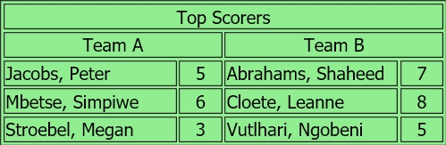
The BLUE table should look like this:
Save and close the web page.
Activity 6 – General
Extract the file from the LionLove compressed file to your exam folder.
Use WinZip / other file extractor

